Title of oral presentation or poster (Times New Roman, 14 pt, bold, centered)
J. Nowak, A. Kowalski (presenting author underlined, Times New Roman, 12 pt., centered)
Department of Nanomaterials Physicochemistry, West Pomeranian University of Technology in Szczecin, 17 Piastów Avenue, 70-315 Szczecin, Poland
e-mail: jaroslaw@nowak.pl (e-mail address of the presenter)
(Times New Roman, 10 pt. centered, italics, when different affiliations distinguish with Arabic numerals in superscript)
In order to standardize and accelerate the process of editing abstracts submitted to the Conference “Graphene and other 2D materials and please use this format. Abstracts of speeches in other format will not be accepted. Please format the text of the abstract as follows: font Times New Roman 12 pt, justified, single line spacing, paragraph indentation 1.25 cm. The abstract file should be saved in .docx (preferred), .doc or .rtf format.
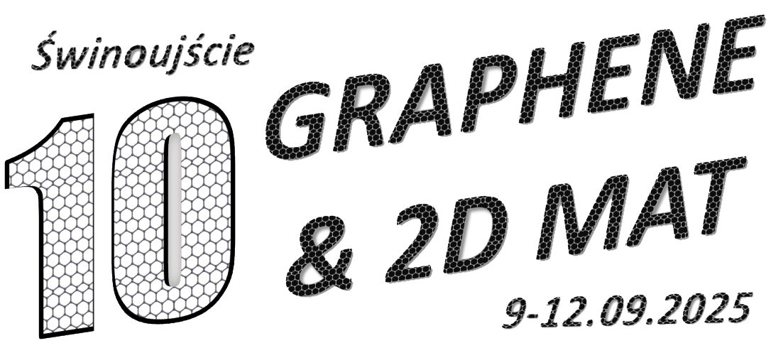
Figure 1, Figure caption format: Times New Roman, 10pt, centered
The abstract must be prepared in English. It must not exceed the length of one page including all figures, diagrams and endnotes. Page margin settings: top 2.5cm, left 2.5cm, right 2.5cm, bottom 2.5cm.

References:
[1] J. van der Geer, J.A.J. Hanraads, R.A. Lupton, J. Sci. Commun. 163 (2000) 51-58
[2] W. Strunk Jr., E.B. White, The Elements of Style, third ed., Macmillan, New York, 1979
Acknowledgements (Times New Roman, 10 pkt., italics)
Content of acknowledgements.

